PORTFOLIO PROJECT

CHAPTER-1

Video Introduction:-

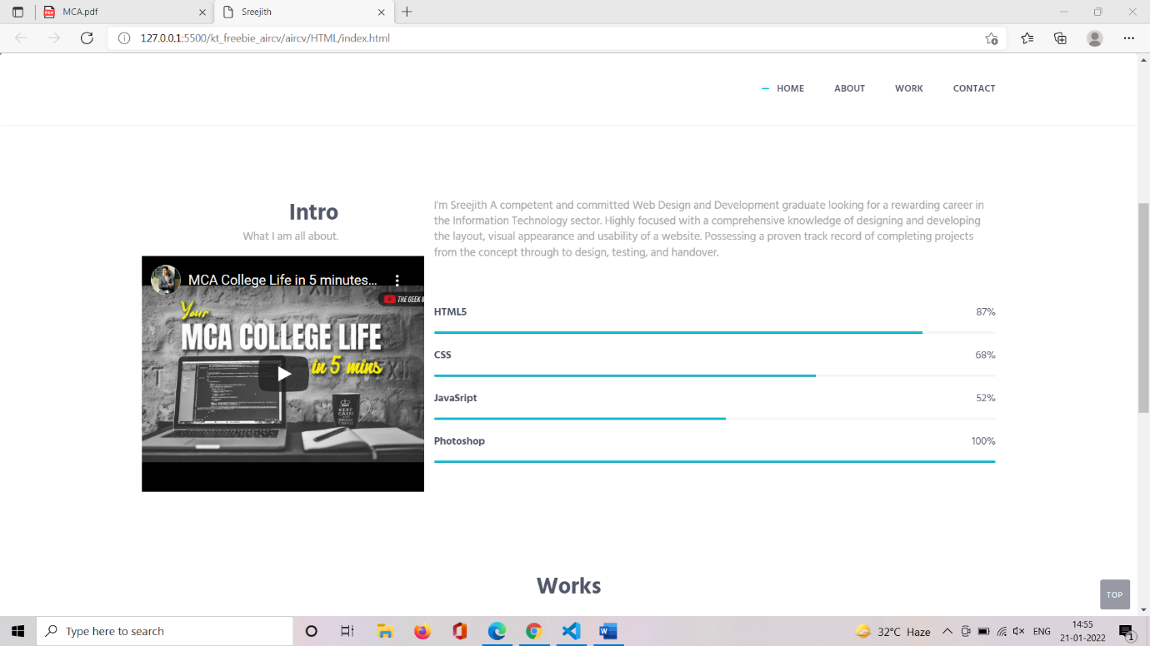

CHAPTER-2

Website Bio Score:-

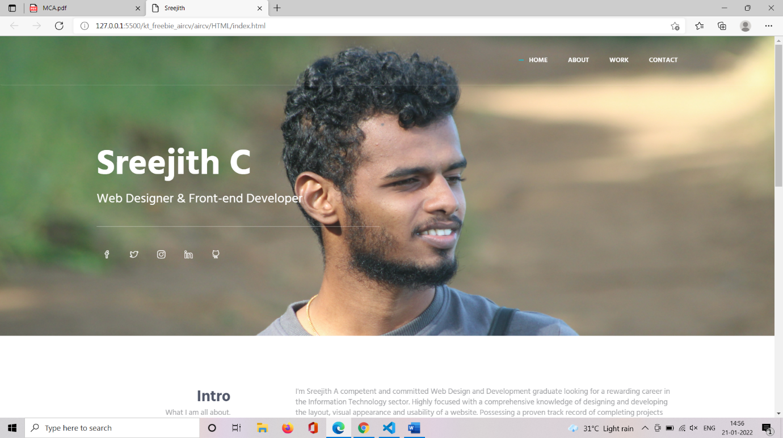

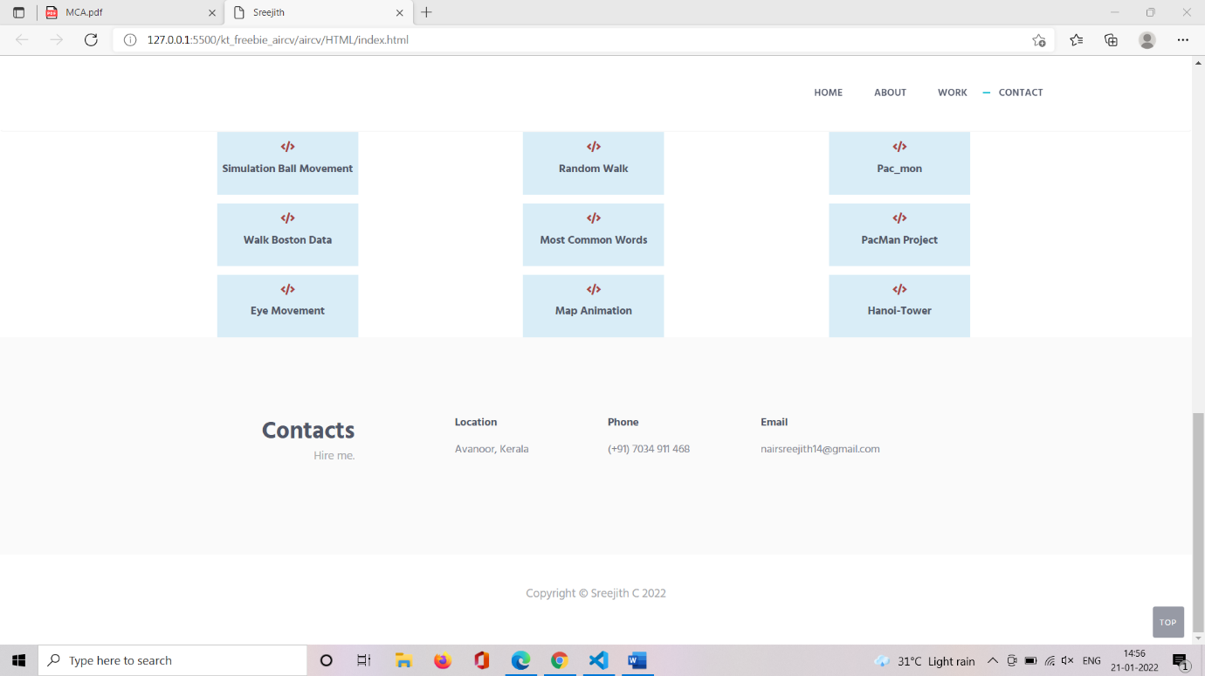

CHAPTER-3

Pages & Navigation:-

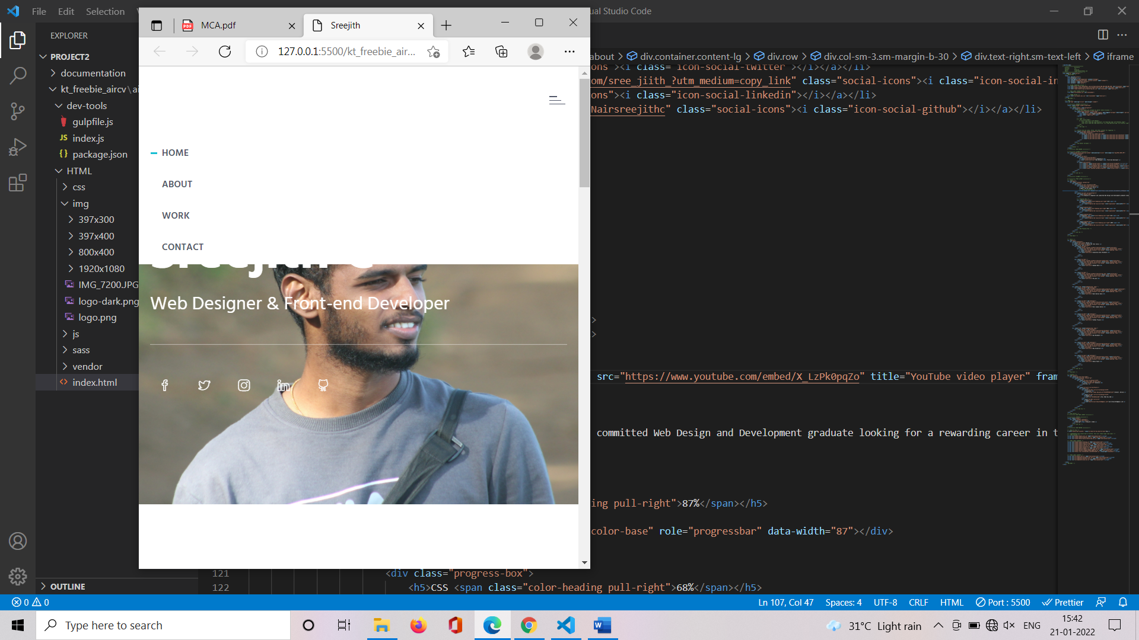

CHAPTER-4

Styles Score:

Font-http://fonts.googleapis.com/css?family=Hind:300,400,500,600,700

CHAPTER-5

Project Links to Github:

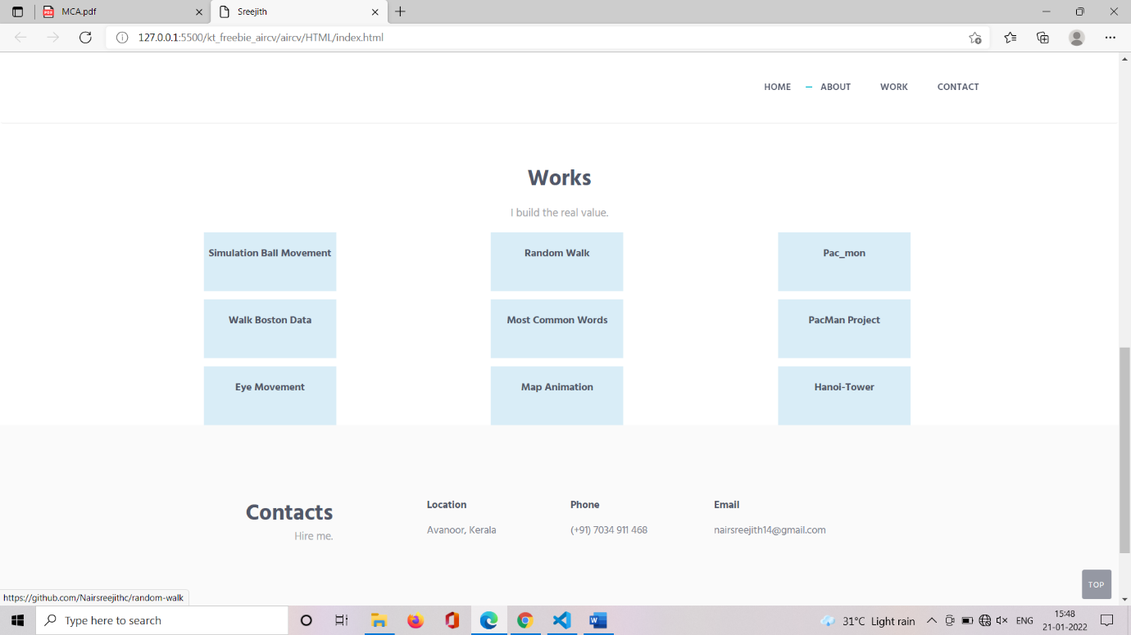

CHAPTER-6

Bootstrap:-

<link href="vendor/bootstrap/css/bootstrap.min.css" rel="stylesheet" type="text/css"/>

CHAPTER-7

Project README:-

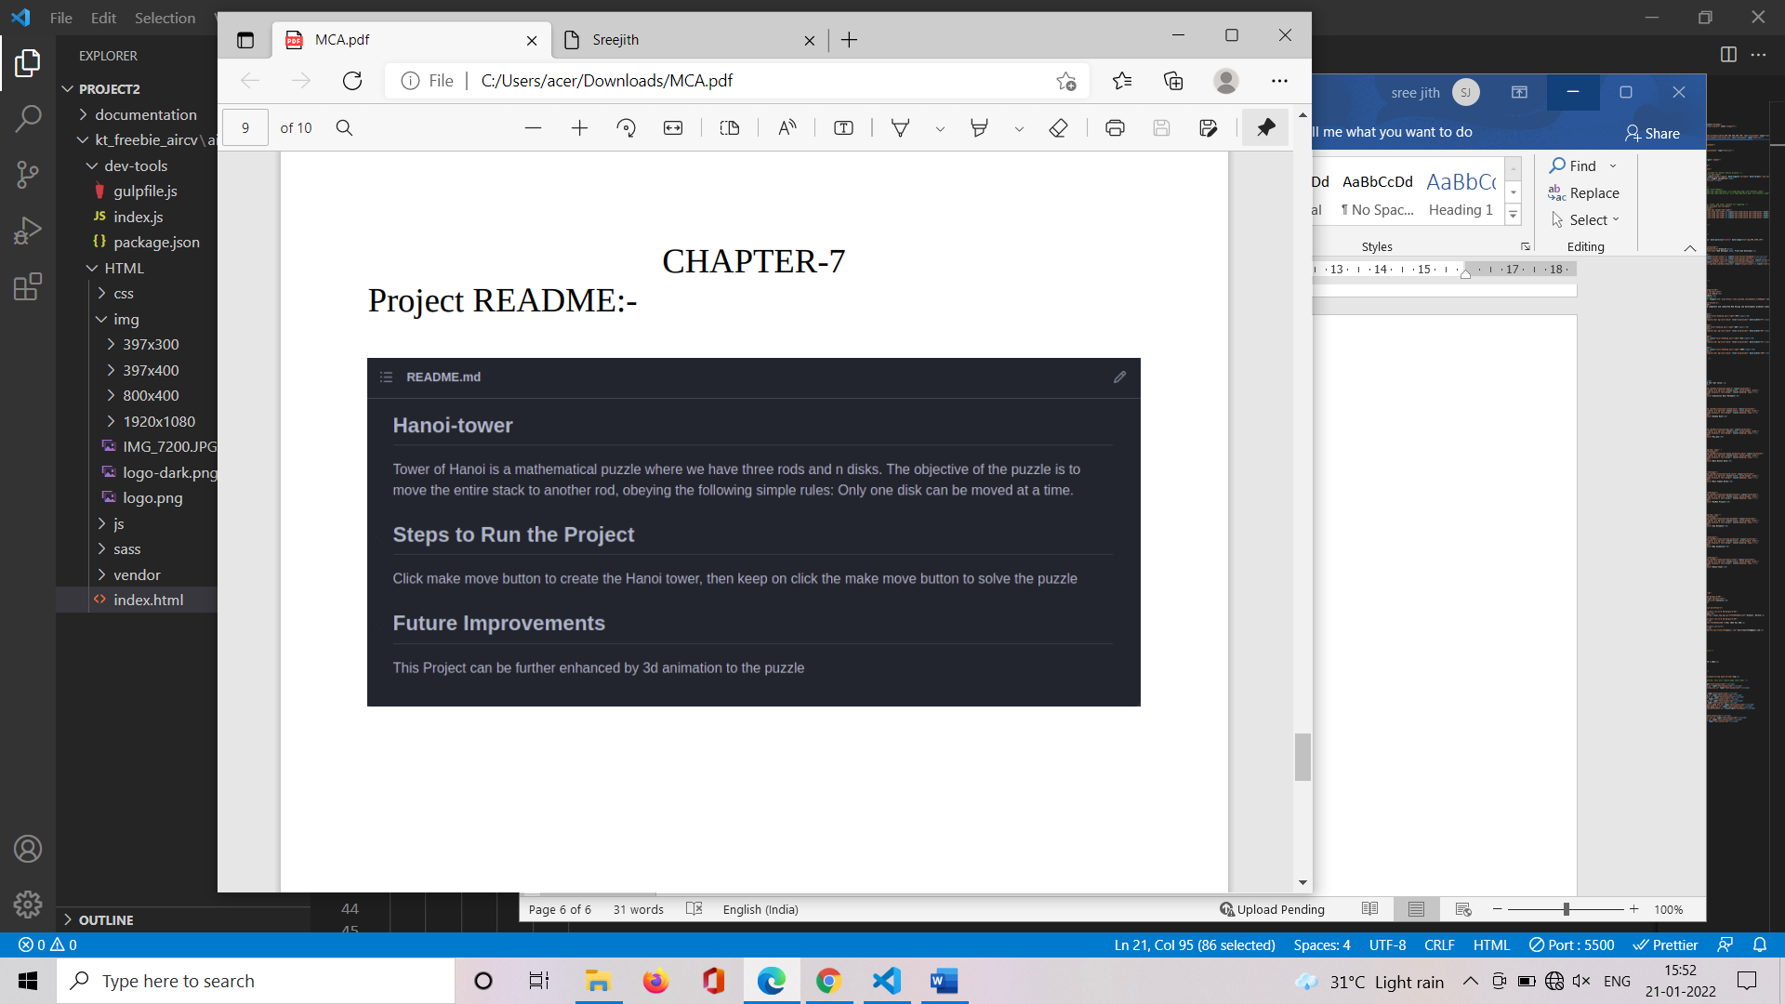

CHAPTER-8

File Structure:

